Trending Data Collecting Methods:

Questionnaires:

Given a source as a stimulus, subject’s emotional states is recorded in questionnaires and scaling is done based on its degree.

Performing Gesture:

Given an emotion state, subjects are asked to perform gestures for that.

Applications:

Applications recording day to day gesture activity is created and tested with the subjects.

Out of these three methods, Questionnaires is used in most cases.

**Abstract Emotion States:**

High control / power

High negative state

High positive state

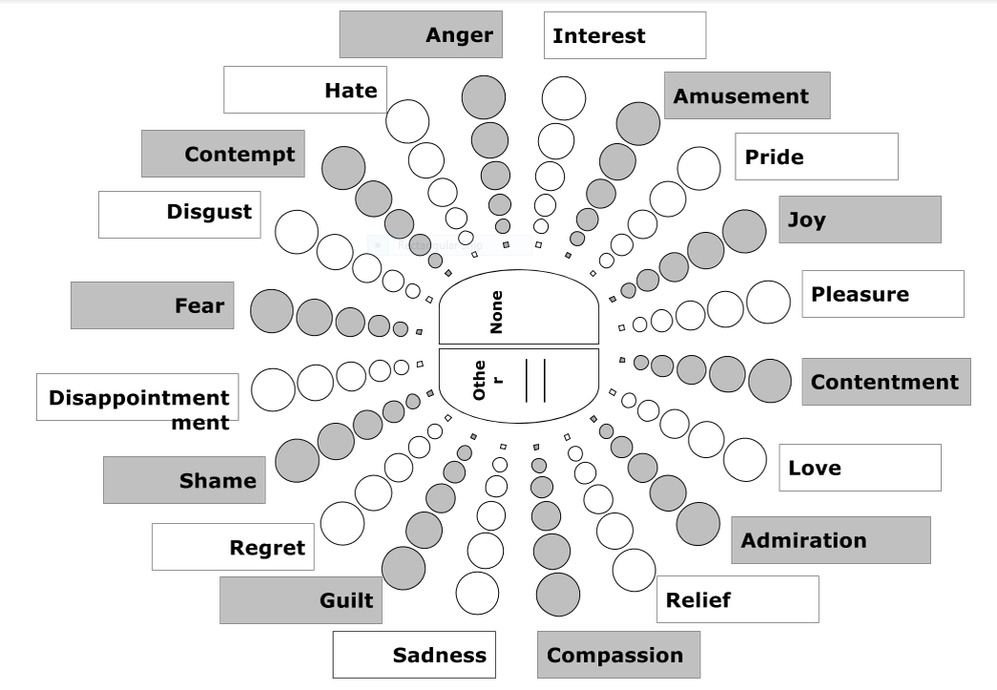

Low positive state

Low negative state

Negative valance

Positive valance

Low control / power

**Touch Properties:**

1. Pressure
2. Speed
3. Length

**Revised Data Set Format:**

**T1 Walking (low acceleration)**

|  |  |  |  |  |
| --- | --- | --- | --- | --- |
| **Time Stamp** | **t1a** | **t1b** | **t1c** | **t1d** |
| **Gesture** | **Click** | **Click** | **Click** | **Swipe** |
| **Touch Property** | **Pressure** | **Pressure** | **Pressure** | **Speed, length, Pressure** |

**Gesture Properties:**

|  |  |  |
| --- | --- | --- |
| Event | Abbreviation | Properties |
| Click | C | Pressure |
| Swipe | Sw | Length (speed) , Pressure |
| Scroll | Sc | Length (speed) , Pressure |

Activity Value (AV) = average of values of gesture events in a particular sub interval.

Pressure is directly proportional to AV.

Assumptions:

1. If Length and Pressure are directly proportional, only Pressure is considered for evaluation.

Possible cases for assigning values to gesture events for each sub interval:

1: Assign values for each timestamp .

2: Assign values as an average for particular gesture event in each sub interval .

**Gesture AV in the interval 6 sec:**

|  |  |  |  |
| --- | --- | --- | --- |
| Gesture event | c,c,c,sw,c,,c,sc,c | c,sw,sc,c,c,c,c,c | c,sw,c,c,c,c,sc,c,c |
| Activity value | X p | Y p | Z p |
| Sub interval | 2sec | 2sec | 2sec |
| Full interval | 6sec | | |

|  |  |  |  |
| --- | --- | --- | --- |
| Gesture event | c,c,sw,c,,c,sc,c | c,sw,sc,c,c | c,sw,c,c,c |
| Activity value | X p | Y p | z p |
| Sub interval | 2sec | 2sec | 2sec |
| Full interval | 6sec | | |

Graph representing the Gesture Activity Value to Abstract Emotion State

